Fifth Grade Spanish
March 23-26
Hola amigos!!
I miss you all so much! I hope you are going outside to play in this nice weather. I also hope you are enjoying time with your “familia”.
Here are some activities for you to practice your Español!
- Teach someone at home the numbers 1-60 and all the tricks and strategies we discussed, i.e. the beginning of the ten group words in Spanish is similar to the ones, like seis (6) – sesenta (60)
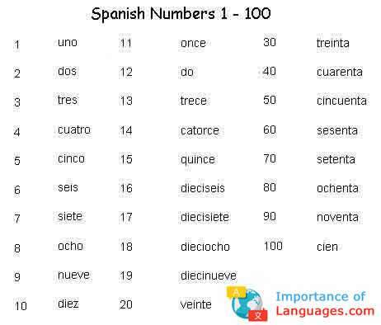
- Use a clock to practice telling time in Spanish. It is 11:30= Son las once y treinta.
- Watch the Rockalingua video “Que hora es” . https://rockalingua.com/songs/what-time-it
Make some predictions about why Señora jokingly refers to past the half hour as “the dark side”. Is it different than what we have learned in class? Can you figure it out? Don’t worry if you can’t. Next week’s lesson will explain it all.

I will post more activities next week.
Virtual ((abrazos))-hugs
Señora

